Character Journal

Answer the following questions:

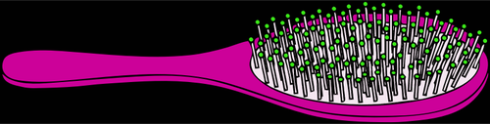

1. If you were this hairbrush, what would you tell us about your life? I would tell you that I am a hairbrush, I can’t move, I can’t talk, and I am used for combing hair all the time.
2. What kind of voice would you have? I would have a low pitched voice.